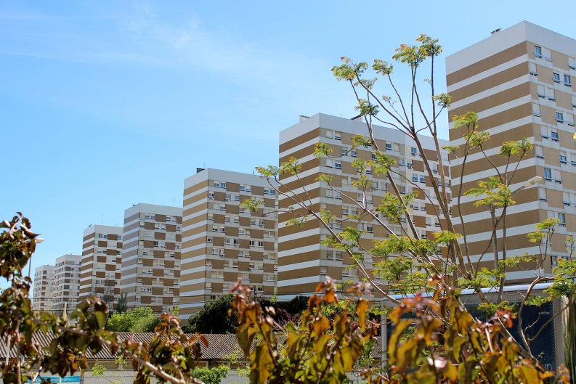

OPTIMISTIC SUBURBIA

INTERNATIONAL CONFERENCE

20-22 May 2015

Registration form

Participant
Paper to be presented: ________________________________________________________________
Presenting author: ____________________________________________________________________
Organisation: _________________________________________________________________________
Address: ______________________________________________________________________________
E-mail: _______________________________________________________________________________

Fees (Please indicate your choice)
__ Regular fee: €150,00 (includes lunches, coffee breaks, dinner and conference materials)
__ Student fee: €75,00 (includes lunches, coffee breaks, dinner and conference materials). Please attach proof of status.

Extra
__ Guided Tour: €10,00

Special dietary requirements
Please specify: ________________________________________________________________________
______________________________________________________________________________________

Billing Information
Full name:_______________________________________________ VAT number: ________________
Address: ________________________________________________ Town: ______________________
ZIP Code:_______________________________________________ Country: ____________________

Payment
Bank Transfer – IBAN: PT50 0035 0368 00006372930 45; BIC SWIFT: CGDIPTPL
Bank Account name: ISCTE-IUL
Bank name: Caixa Geral de Depósitos

After payment is made, please email the bank slip to fatima.santos@iscte.pt
This bank slip must clearly state the name of the participant (it might be handwritten), as unidentified bank transfers cannot be processed.

